**Bank Microservices – Account & Loan**

This project contains two Spring Boot microservices:

* **Account Service** (port 8080)
* **Loan Service** (port 8081)

Each service returns dummy data via REST API.

AccountController.java

@RestController

public class AccountController {

@GetMapping("/accounts/{number}")

public Account getAccount(@PathVariable String number) {

return new Account(number, "savings", 234343);

}

static class Account {

public String number;

public String type;

public double balance;

public Account(String number, String type, double balance) {

this.number = number;

this.type = type;

this.balance = balance;

}

}

}

Access in browser:  
http://localhost:8080/accounts/1234

LoanController.java

@RestController

public class LoanController {

@GetMapping("/loans/{number}")

public Loan getLoan(@PathVariable String number) {

return new Loan(number, "car", 400000, 3258, 18);

}

static class Loan {

public String number;

public String type;

public double loan;

public double emi;

public int tenure;

public Loan(String number, String type, double loan, double emi, int tenure) {

this.number = number;

this.type = type;

this.loan = loan;

this.emi = emi;

this.tenure = tenure;

}

}

}

Access in browser:  
<http://localhost:8081/loans/H00987987972342>

Output:

<http://localhost:8081/loans/H00987987972342>

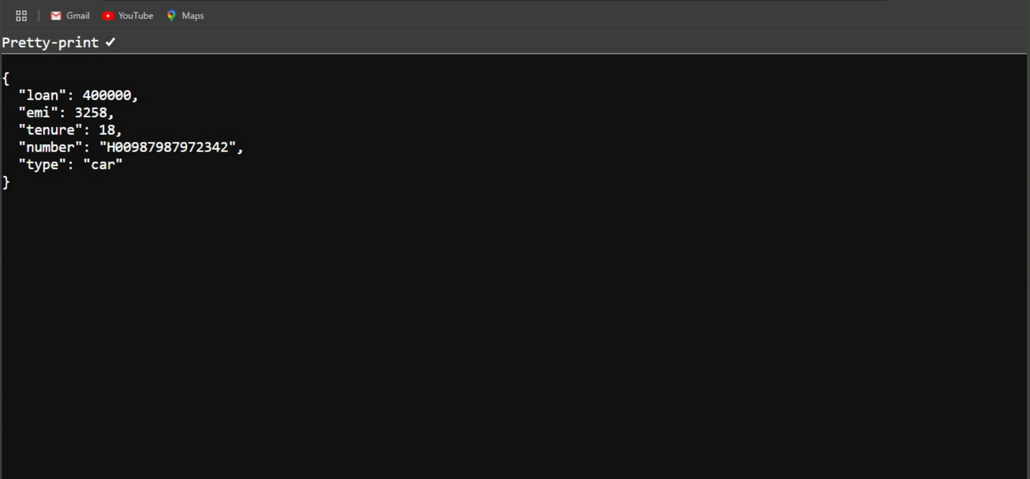

http://localhost:8080/accounts/1234

